
Thank you for purchasing Bowland Stone Products
INSTALLING THIS PRODUCT IS ACCEPTANCE OF QUALITY

Delivered Goods
All products must be checked upon receipt. In the unlikely event of products reaching you in an unsatisfactory condition, please contact your retailer immediately, allowing time for the rejected product to be inspected and or replaced. Minor scuffs or bruises may occur during delivery, movement onsite and installation are generally unavoidable, in our experience these will weather in over time.
Bowland Stone cannot accept any responsibility for uplifting and relaying costs of defective products if upon inspection, it is deemed that the defect would have been apparent prior to laying.

Storage
Prior to laying, it is imperative that paving is stored in a vertical position, ideally with original spacers in between paving (not stored face to face touching) and it is adequately covered. Rain/moisture can become trapped and settle between paving if left open to the elements, causing a drizzle like stain on the surface of the paving (particularly apparent in light coloured products). Bowland Stone will not take responsibility for any paving that has developed water marks/stains due to inadequate storage.

Health and Safety / Product Handling
Care should be taken when handling / installing Bowland Stone products, we always recommend suitable lifting equipment or 2 person lifting on our larger size paving slabs.
- Always wear gloves and safety footwear when handling products
- Wear appropriate PPE if using cutting equipment
- Ensure products are on level ground before unwrapping and the product is supported before cutting bands to avoid breakages, chipping or damage to yourself

Application
Bowland Stone products, unless otherwise stated, are primarily intended for domestic/landscape use only. Decorative paving is not recommended for use on driveways.

Natural Stone Information
Unavoidable colour and thickness variations occur within the natural stone ranges. Our natural stone is sourced from suppliers who are registered with the ‘ethical trading initiative’.

Natural stone may develop added marking, deposites or patches as mineral content oxidises. Product should be mixed from a number of packs prior to installation and should always be laid on a full wet mortar bed.

All Silver Grey Natural Sandstone products vary with differing geological conditions. Such variations can lead to small particles of ironstone within the product creating a darkening of the surface with natural weathering. This natural weathering is more obvious with Silver Grey Sandstone compared to other natural stone products due to its paler colour.

15.3m² Limestone Paving Kit
Laying Guide
4500mm

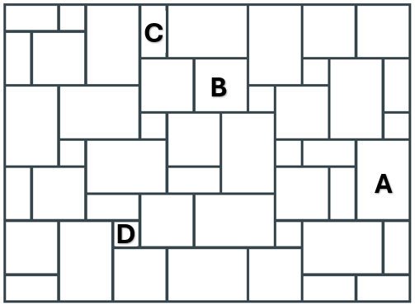

Part | Description | No. in pack
A | 900 x 600 | 13
B | 600 x 600 | 13
C | 600 x 300 | 13
D | 300 x 300 | 9

3400mm

