
Thank you for purchasing Bowland Stone Products
INSTALLING THIS PRODUCT IS ACCEPTANCE OF QUALITY

Delivered Goods
All products must be checked upon receipt. In the unlikely event of products reaching you in an unsatisfactory condition, please contact your retailer immediately, allowing time for the rejected product to be inspected and or replaced. Minor scuffs or bruises may occur during delivery, movement onsite and installation are generally unavoidable, in our experience these will weather in over time.
Bowland Stone cannot accept any responsibility for uplifting and relaying costs of defective products if upon inspection, it is deemed that the defect would have been apparent prior to laying.

Storage
Prior to laying, it is imperative that paving is stored in a vertical position, ideally with original spacers in between paving (not stored face to face touching) and it is adequately covered. Rain/moisture can become trapped and settle between paving if left open to the elements, causing a drizzle like stain on the surface of the paving (particularly apparent in light coloured products). Bowland Stone will not take responsibility for any paving that has developed water marks/stains due to inadequate storage.

Health and Safety / Product Handling
Care should be taken when handling / installing Bowland Stone products, we always recommend suitable lifting equipment or 2 person lifting on our larger size paving slabs.
- Always wear gloves and safety footwear when handling products
- Wear appropriate PPE if using cutting equipment
- Ensure products are on level ground before unwrapping and the product is supported before cutting bands to avoid breakages, chipping or damage to yourself

Application
Bowland Stone products, unless otherwise stated, are primarily intended for domestic/landscape use only. Decorative paving is not recommended for use on driveways.

Sizes
Bowland paving is manufactured to capture the authenticity of natural slabs and as such they may vary in thickness. All sizes & dimensions are nominal, subject to manufacturing tolerances and are for guidance only.
It is recommended to ‘dry lay’ your design first starting from the centre, (especially Bowland Stone feature kits including circles, stars, octagons, & ovals), which will allow you to establish the correct spacing between each slab to ensure your design fits perfectly in the area allocated.

Product Colour
Please note that the colour of new products will inevitably vary compared to those which have been installed for a period of time as weathering does take place. Although every effort is made to ensure colour consistency, variations between production batches can occur, especially in blended shades. We recommend that where possible products are ordered from one batch and where multiple packs of product are ordered, thoroughly mix the products by drawing from different packs when laying.

Weathering
Natural weathering and site conditions will also affect the appearance of paving along with seasonal manufacture or naturally occurring variations of the aggregates used in manufacturing.
Differential weathering can cause patchy, dark discolouration on the surface of individual paving slabs, due to the paving curing at different rates. This will generally diminish over time and will not affect the long term performance.
All products can develop algae and organic growths under certain environmental conditions and may require cleaning. Areas adjacent to borders, plant pots and trees may discolour from transfer of plant life. Specialist maintenance advice may need to be sought.
Cathedral 2.56m Patio Pack
Laying Guide
3000mm (with Infills)
2560mm

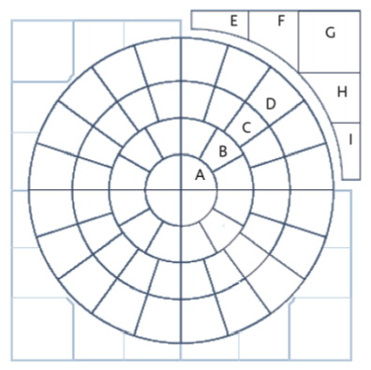

Part | Description | No. in pack
A | Radius 1 | 4
B | Radius 2 | 12
C | Radius 3 | 20
D | Radius 4 | 20
E | Square Off Left | 4
F | Square Off Middle (L) | 4
G | Square Off Centre | 4
H | Square Off Middle (R) | 4
I | Square Off Right | 4

Cathedral Circle Radius Pieces
All sizes are approximate
